**15 Aug 2014** **The Weekly Bulletin of Rotary Club of Kathmandu Mid-Town** **bc-07/8.014**

|  |
| --- |
|  |

District: 3292 Web:www.rotarymidtown.org.np Club Id: 26776

**AUGUST IS MEMBERSHIP & EXTENSION MONH**

**Celebrating**

**25 Years in Rotary**





Friday, 8 August : Extracts of the Minutes # 1241

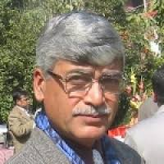

**Dr Shambhu Ram Simkhada**, the Guest Speaker, was introduced to the meeting by

Rtn Bhairaja. Dr Simkhada served as Ambassador and Permanent Representative of

the Kingdom of Nepal to the United Nations during late nineties.

“Dr. Shimkhada spoke about Nepalese Leadership and the Road Ahead.

He hailed the recent Modi’s visit to Nepal. He stressed the need for leadership

with ideas. He said that the book “march of folly” by Barbara Tuchman is

worth reading.”

“Rtn Govinda, PP Walter, Rtn Pavitra participated during the interaction. PP William gave vote of thanks.”

><><><><><><><><

Information Sharing:

“Rtn Peter Reid informed that TED speaker Hans Rosling is in Kathmandu;

RCC Rishi informed that his village is looking for Rotary support for Drinking water;

Rtn Rabi informed that PP Late Pratap’s son joined Rotary in San Francisco;

President and PP Ajay might join the District Membership Development Seminar to be held on 16 August;

There was discussion about how to make use of the Disaster Relief Fund, effective way to address the Sun Koshi disaster;

Mrs Meena Vaidya Pandey donated Rs 20,000 for addressing the Sun Koshi disaster;

Treasurer Jo requested all members to pay their membership dues.”

Members present: 21

# Weekly Meetings and Prorams :

|  |  |  |
| --- | --- | --- |
| Date | Program/Speaker | Program/Topics of Presentation |
| 15 August | Rtn Radesh Pant | Investment climate in Nepal |
| 22 August | ?? |  |
| 29 August | ?? |  |

**Friday, 15August :**

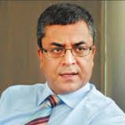

In-house Speaker Rtn Radesh Pant will be giving a short talk on “Investment Climate

in Nepal”.

The Government of Nepal appointed Rtn Radhesh Pant as the Chief Executive of

Nepal Investment Board on 28 Nov, 2011.  The Investment Board is envisioned to give

a one-window solution to potential investors in big projects over Rs 25 billion with

the chairmanship of the Prime Minister of Nepal.

Before this appointment he was working as the CEO of Kumari Bank and prior to that

CEO of Bank of Kathmandu.

Rtn Pant is B.Tech. from Indian Institute of Technology, Bombay and an MBA from the University of California, Los Angeles.

**[](http://www.un.org/esa/socdev/unpfii/documents/ip-day/2014/ip-day-prog-2014.pdf)World Indigenous Day**: 9 August

The [International Day of the World's Indigenous Peoples](http://undesadspd.org/IndigenousPeoples/InternationalDay/2014.aspx)is commemorated annually on 9 August in recognition of the first meeting of the UN Working Group on Indigenous Populations, held in Geneva in 1982. There are an estimated 370 million indigenous people in some 90 countries around the world who constitute 15 per cent of the world's poor and about one third of the world's 900 million extremely poor rural people. Practicing unique traditions, they retain social, cultural, economic and political characteristics that are distinct from those of the dominant societies in which they live.

The UN Declaration on the Rights of Indigenous Peoples, adopted by the UN General Assembly in 2007, recognized their right to self-determination and to freely pursue their economic, social and cultural development. This year's theme, “Bridging the gap: implementing the rights of Indigenous peoples” also marks the 20th anniversary of the celebration, which dates back to 1994.

Marking the International Day of the World's Indigenous Peoples today, United Nations [Secretary-General](http://www.un.org/sg/) Ban Ki-moon said indigenous peoples have a central interest in development and can act as “powerful agents of progress.” “In order for them to contribute to our common future, we must secure their rights,” said Mr. Ban in his [message](http://www.un.org/en/events/indigenousday/2014/sgmessage.shtml) on the Day, in which he added: “Let us recognize and celebrate the valuable and distinctive identities of indigenous peoples around the world. Let us work even harder to empower them and support their aspirations.”

“Historical injustices have all too often resulted in exclusion and poverty,” Mr. Ban said, adding that power structures continue to create obstacles to indigenous peoples' right to self-determination.

><><><><><><><><

**Rakshya Bandhan** : 10 August

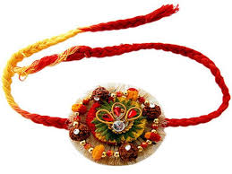

Raksha Bandhan or Rakhi is a Hindu festival marked by the full moon in the month

of Shrawan. The word Raksha Bandhan means the bond of protection. It symbolises

the love and affection between a brother and sister as well as the solemn vow that

every brother takes to protect his sister. Rakshabandhan is the festival that adds on

love, and strengthen the beautiful relationship of brother and sister.

Rakhi is basically a sacred thread of protection embellished with the love and

affection of a sister for her brother. This frail of thread of Rakhi is considered as

stronger than iron chains as it binds the most beautiful relationship in an inseparable

bond of love and trust. Rakhi festival also has a social significance because it

underlines the notion that everybody should live in harmonious coexistence with each other.

Rakhi or Rakshabandhan is also celebrated between those who shares a caring relationship between each other, whether they are biologically related or not. Cousin brothers and sisters also celebrate Rakhi and shares the same bond of love and care.

><><><><><><><><

**Gaijatra:** 11 August

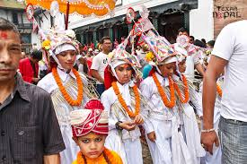

The festival of “Gaijatra”, the procession of cows, is generally

celebrated in the Valley in the month August. The festival is one of

the most popular festivals of Nepal. According to the traditions since

times immemorial, every house-hold having a death in the family

during the past year must participate in the Gaijatra procession through

the streets of Kathmandu, Lalitpur or Bhaktapur leading a cow.

In Hinduism, a cow is regarded as the most venerated among all the

domestic animals. There is a belief that after death one has to cross a

vast sea *Baitarani* to reach Heaven, and it will be easier to cross over

the sea with the help of a cow. So people decorate cows in the name of their deceased relatives and pray to God for their quick arrival to Heaven. People who do not have cow they decorate young kids to go on procession in place of cows. Gaijatra procession is taken through the given tracks of the cities to show people that the death is the truth in life and everybody has to face it one day.

Modern day Gaijatra added other flovors to the festival in consistence with traditional values, King Pratap Malla, (Malla Era) had established. Various street shows, theatre shows are organized and played, special gaijatra programs are aired in TV channels, special editions of weeklies are published in commemoration of gaijatra celebration.

*Source:* Internet News

**Rotary Information:**

**Membership Development Seminar**

Let us strengthen our efforts to contribute in increasing Rotary membership – the more hands we have, more services we can deliver to communities. Here is an opportunity: participate in Membership Development Seminar which is going to be held on Saturday, 16 Aug at Hotel Everest. This is an RID 3292 program. The details are as follows:

Date: Saturday, 16 August 2014

Venue: Hotel Everest, New Baneswor

Registration: 8:00 to 9:00 hrs, Registration fee: Rs. 1,500

Program starts at 9:00 hrs and followed by lunch

Regional coordinator PDG Vijay Jalan and Asst. Rotary Public Image Coordinator PDG Anirudha Roy Chowdhury will be the Keynote Speakers.

><><><><><><><><

**Sunkoshi Landslide Crisis:**

Relevant extracts from RID 3292 decisions and recommendations for needful action and cohesive preparedness in Rotary fraternity:

District Disaster Relief Committee is in contact with Armed Police Force from Day 1 discussing the situation and taking suggestions since RID-3292 already signed a MOU with APF recently on Disaster Management and Relief.

District-3292 to provide Rs 100,000 seed money provision from Disaster Relief Fund Interest.

District-3292 will act in partnership with APF as per our mutual MOU.

A quick Rehabilitation Program is in discussion and is in the process including health camp, medical referral, scholarship, infrastructure, economic development and other Rotary service projects in the affected area.

Aquabox distribution: 50 in Kath valley, 30 each in 5 Development Regions.

On Lighter Side :



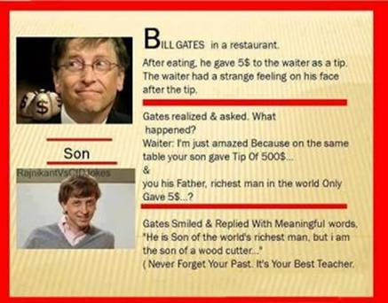

*Courtesy: Rtn Isabella CB Khadka*

Great quotes :

*[Life is a song - sing it.](http://www.brainyquote.com/quotes/quotes/s/saibaba176928.html" \o "view quote)*

*[Life is a game - play it.](http://www.brainyquote.com/quotes/quotes/s/saibaba176928.html" \o "view quote)*

*[Life is a challenge - meet it.](http://www.brainyquote.com/quotes/quotes/s/saibaba176928.html" \o "view quote)*

*[Life is a dream - realize it.](http://www.brainyquote.com/quotes/quotes/s/saibaba176928.html" \o "view quote)*

*[Life is a sacrifice - offer it.](http://www.brainyquote.com/quotes/quotes/s/saibaba176928.html" \o "view quote)*

*[Life is love - enjoy it](http://www.brainyquote.com/quotes/quotes/s/saibaba176928.html" \o "view quote).*

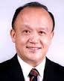

Be active. You have one year - 365 days. They are going to go by very fast. The year will be over before

you know it, and you are going to ask yourself, “What did I do?

**RI President GARY C.K. HUANG**

Please send information on club activities, progress reviews on service projects, relevant photos etc to:

BC Editor: RR Shrestha email: rryesrr@gmail.com

## 15 August 2014 The Weekly Bulletin of Rotary Club of Kathmandu Mid-Town bc-07/8.014